OS Lab 2
Q1:
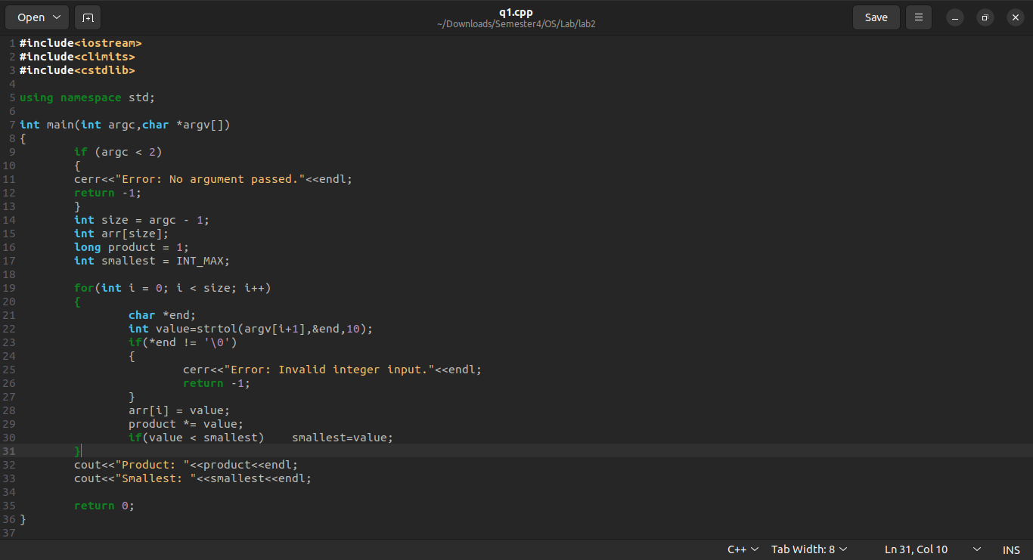
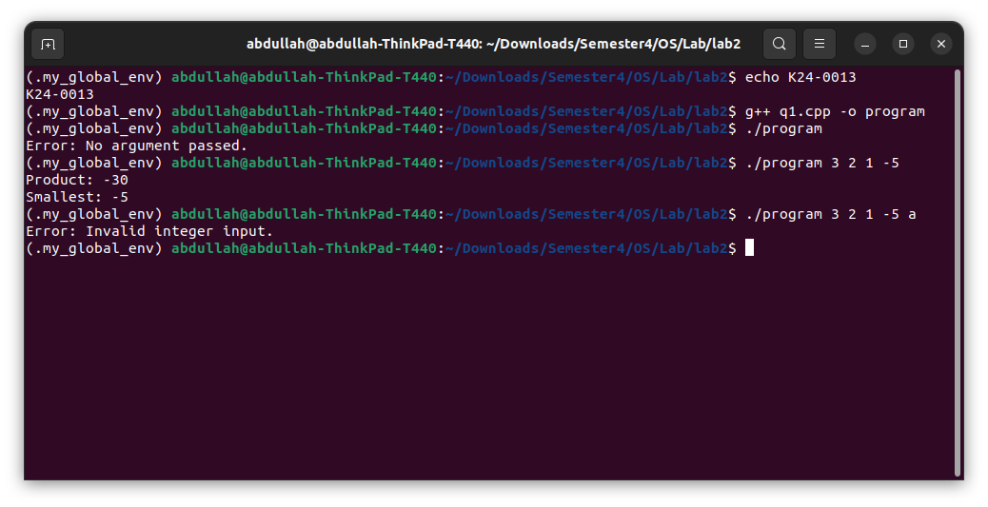
Q2:
#include<iostream>
#include<fstream>
#include<cstdlib>
using namespace std;

int main(int argc, const char* argv[])
{
if (argc < 3)
{
cerr<<"Error: At least 2 numbers are required."<<endl;
return -1;
}
int size = argc - 1;
int arr[size];
//checking input
for (int i = 0; i < size; i++)
{
char *end;
int value = strtol(argv[i+1], &end, 10);

if(*end != '\0')
{
cerr<<"Error: Invalid Integer input: "<<endl;
return -1;
}
arr[i] = value;
}
//difference
int diff = arr[1] - arr[0];
for(int i = 1; i < size - 1; i++)
{
if(arr[i+1] - arr[i] != diff)
{
cerr<<"Error: Sequence pattern not consistent."<<endl;
return 0;
}
}
int next = arr[size - 1] + diff;
cout<<"Next number in the sequence: "<<next<<endl;
ofstream file("result.txt");
if(!file)
{
cerr<<"Error: Could not create file."<<endl;
return -1;
}
file<<next;
file.close();
return 0;
}
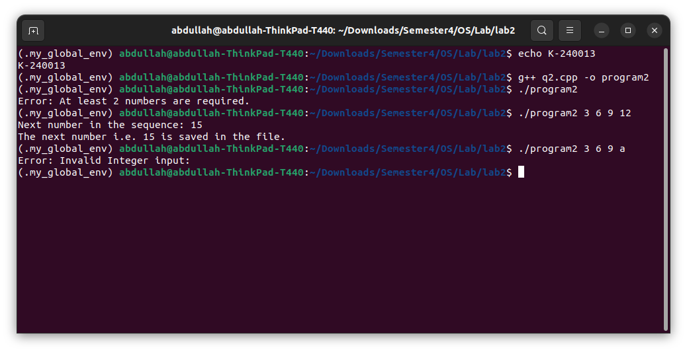
Q3:
#include<iostream>
#include<fstream>

using namespace std;

int main()
{
ifstream file("data.txt");
if(!file)
{
cerr<<"Error: file not found."<<endl;
return -1;
}
int arr[1000];
int count = 0;
int max;

if(!(file>>arr[0]))
{
cerr<<"Error: file is empty."<<endl;
return -1;
}

max = arr[0];
count++;

while(file>>arr[count])
{
if(arr[count]>max) max = arr[count];
count++;
}
file.close();

cout<<"Total numbers: "<<count<<endl;
cout<<"Largest number: "<<max<<endl;

ofstream file2("max.txt");
if(!file2)
{
cerr<<"Error: file max.txt can not created."<<endl;
return -1;
}
file2<<max;
cout<<"The largest number i.e. "<<max<<" is written in the max.txt file."<<endl;
file2.close();
return 0;
}
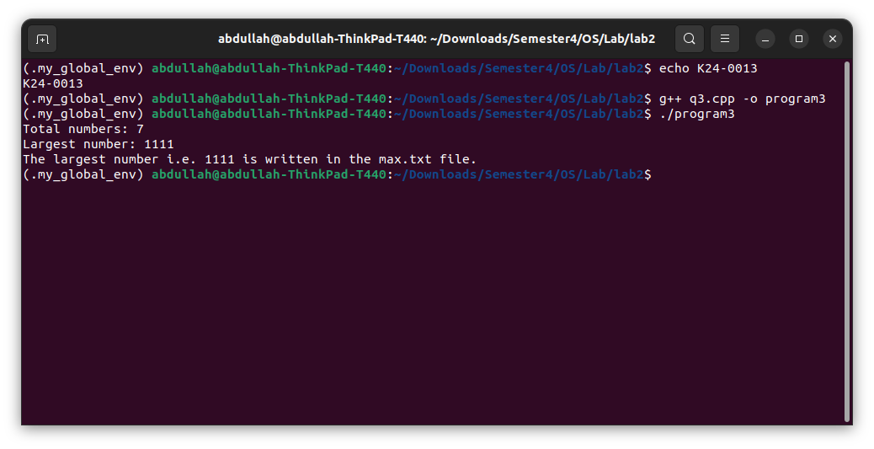
Q4: